EXPRESSION OF INTEREST- MEMBER OF EDITORIAL BOARD/
REVIEW PANEL

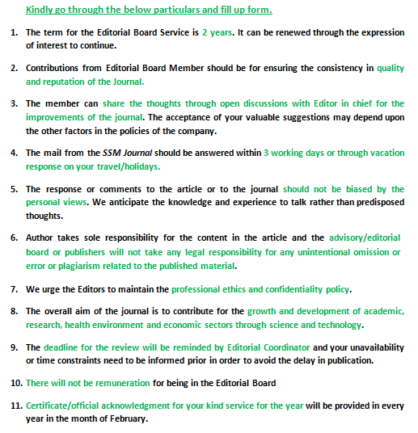
Title:

First name: Surname:

Designation: Department:

Affiliation:

Date of Birth: Nationality:

Highest Degree obtained: Major:

Address for communication:

Contact number with country code:

Mail id:

English language proficiency: Excellent/Very good/Good/Average

Number of papers published:

Number of publications where you are serving in editorial board:

Area of expertise (You can select multiple options as well as add new areas):

Agricultural Science/Animal Science/Plant Science/ Microbiology/Computational Biology/Environmental Science/Food Science/Bio energy science

Are you member of SCIRE/SESR:

SCIRE/SESR Membership number: __________________

How did you know about us? : Mail/Website/Magazine/Colleague

I, ____________________________________would like to express my interest to be a part of Editorial Members of Scire Science Multidisciplinary Journal
Name:
Date: Please send the completed form to
info@scire.co.in or scireinfo@gmail.com
Contact us at +91- 790 725 8764 for any queries.

